TIM Webinar on Biomanufacturing

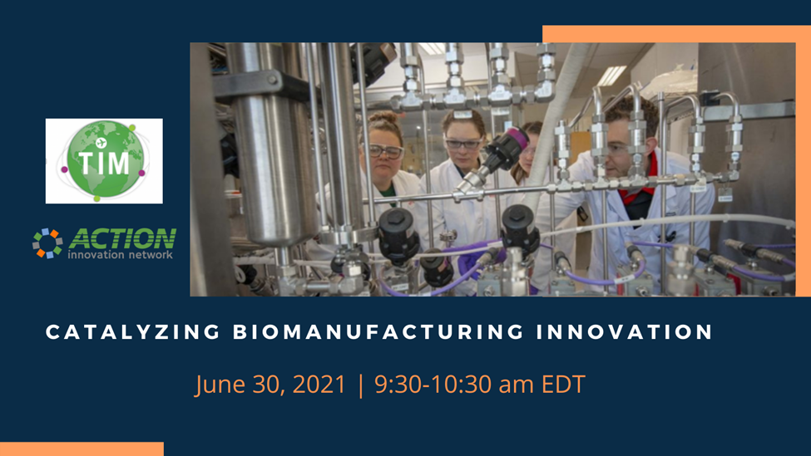

Join Twins International Multihelix (TIM) members for a presentation on biomanufacturing. Hear brief presentations from several TIM partners about the state of biomanufacturing in their regions. You will learn about biomanufacturing initiatives and bio-ready regions in Massachusetts as well as workforce shortages and training programs. Share gaps, challenges, and explore solutions within your life science hub.

Agenda:

9:30 -9:35 Opening: Ursula Hultkvist Bengtsson, Twins International Multihelix (Sweden)

Joan Popolo, ACTION Innovation Network (US)

9:35-9:45 Jon Weaver, President, Massachusetts Biomedical Initiatives (US)

9:45- 9:55 Benjamin Bradford, VP of Membership & Economic Development, MassBio (US)

9:55-10:05 Celina Chang, VP of Science Operations, Lab Central (US)

10:05-10:15 Martine Courtemanche, Director of Business Services, Life Science and Micro-Nanotechnologies, Sherbrooke Innopole (Canada)

10:15- 10:30 Q&A and discussion

Join Zoom Meeting

<https://us02web.zoom.us/j/89923733137?pwd=WTU3V1VpaGh4UTAraGZBVitVdytKdz09>

Meeting ID: 899 2373 3137 Passcode: 162972

Reference: *Why the Boom in Biomanufacturing is Just Getting Started*, <https://www.bisnow.com/national/news/life-sciences/why-the-boom-in-biomanufacturing-is-just-getting-started-109187>