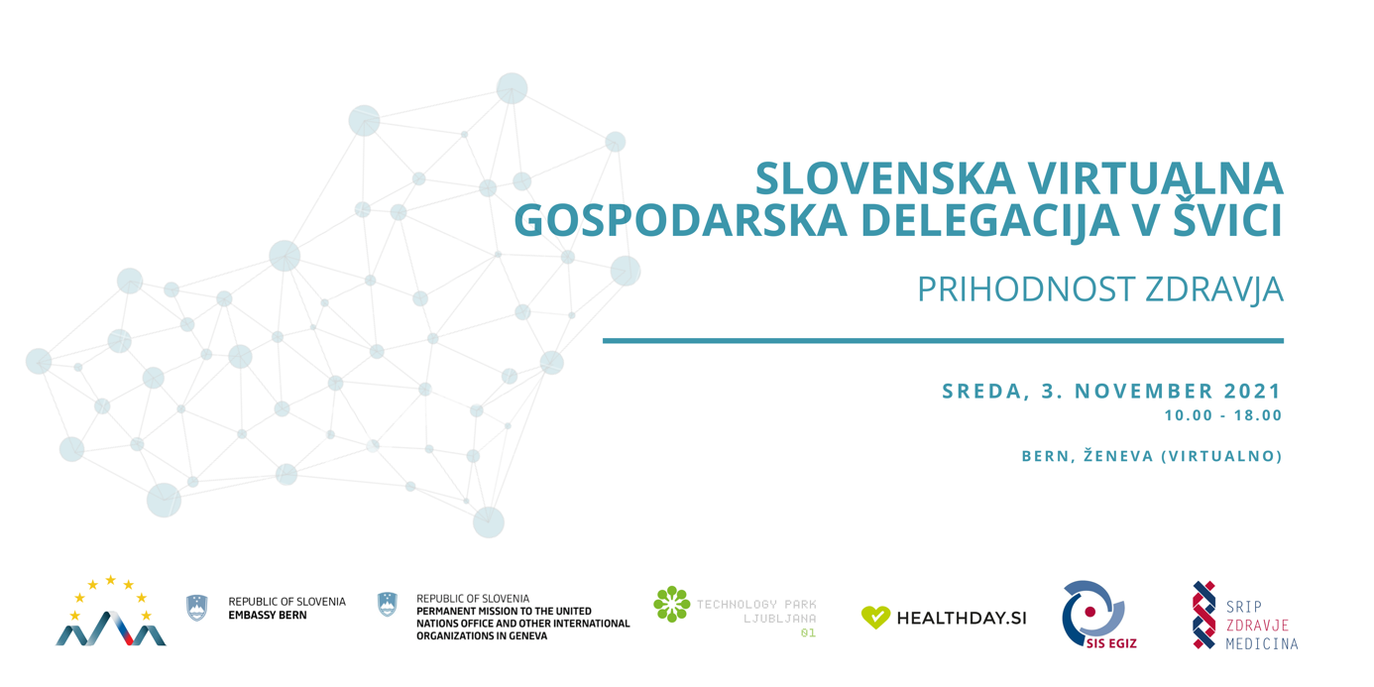

Slovenska virtualna gospodarska delegacija v Švici
Prihodnost zdravja

Sreda, 3 November 2021
Bern, Ženeva (virtualno)

Veleposlaništvo Republike Slovenije v Bernu in Stalno predstavništvo Republike Slovenije pri Uradu ZN in drugih mednarodnih organizacijah v Ženevi vas v sodelovanju z največjo slovensko skupnostjo za inovacije v zdravstvu HealthDay.si, Slovenskim inovacijskim stičiščem SIS EGIZ ter SRIP Zdravje – medicina vabi k sodelovanju v slovenski virtualni gospodarski delegaciji s področja prihodnosti zdravja, e-zdravja in medtech-a, ki bo Švico obiskala v sredo, 3. novembra 2021 med 10. in 18. uro.

Virtualni program bo zajemal predstavitev in delavnico o vstopanju na švicarski trg, poslovanju na švicarskem trgu ter relevantnih zakonodajnih okvirih s posebnim poudarkom na področju tehnoloških podjetij s področja zdravja. Spoznali bomo najboljše poslovne prakse na slovenskem in švicarskem trgu ter tkali nove stike in poznanstva na tem naprednem trgu. V sodelovanju s Svetovno organizacijo za intelektualno lastnino s sedežem v Ženevi bodo udeležena podjetja spoznavala pomen vrednotenja intelektualne lastnine in pomembne podrobnosti, ki jih morajo upoštevati tehnološka podjetja, v sodelovanju z Mednarodno zvezo za telekomunikacije pa bodo mlada zagonska podjetja svoje rešitve predstavila panelu strokovnjakov (pitching) s področja prihodnosti zdravja in tehnologij. Program bo zaokrožala tudi javna panelna razprava o priložnostih, ki jih predstavlja umetna inteligenca na področju javnega zdravja in medicine.

Dogodek bo v celoti potekal v angleškem jeziku.

Prijave zbiramo do 27. oktobra 2021 na povezavi.

Dodatne informacije: monika.klemencic@sis-egiz.eu ali urska.rauter@tp-lj.si.

PROGRAM

10.00 – 10.15 | Introduction  - Ambassador Iztok Grmek, Ambassador of the Republic of Slovenia to Switzerland  - Ambassador Anita Pipan, Permanent Representative of the Republic of Slovenia to the UN Office and other international organizations in Geneva  - Ambassador Denis Knobel, Ambassador of the Swiss Confederation to Slovenia
10.15 – 11.15 | Doing Business in Switzerland + Q&A  Swiss Medtech Market  - Dr. Patrick Dümmler, Clustermanager, Health Tech Cluster Switzerland  Regulatory Framework and Business Opportunities  - Karina Candrian, Co-founder & Partner Medicalboard (TBC)
11.15 – 12.30 | Best Practice presentation + Q&A  Entry to the Swiss Market  - Igor Rogelj, Head at ArrowFast & Diego Casadei, General Manager Cosylab Switzerland  Collaboration with the regional ecosystem  - Nina Remškar, Strategic Healthcare Partner, Roche Slovenija  Experiencing collaboration with SMEs  - Lek (TBC)
Lunch Break

13.00 – 15.00 |  | 14.00 – 15.00
Meet the game-changing digital health startups from Slovenia – Live pitching session  In cooperation with International Telecommunication Union (ITU).  Meet the top Slovenian entrepreneur finalists present their innovative digital health care solutions. Co-organized with the Permanent Mission of Slovenia in Geneva, Embassy of Slovenia in Bern, HealthDay.si community and Slovenian Innovation Hub / SRIP Health – Medicine, this AI for Good Innovation Factory pitching session will be showcasing five Slovenian start-up entrepreneurs whose solutions use the power of AI for global health and well-being.  Urška Rauter from HealthDay.si will kick off the session with an overview of Slovenia's health startup ecosystem, and three medtech judges will join the session with the pitching startups.  More info & registration. |  | Panel discussion: Harnessing AI's power for Health  In cooperation with the European Union Delegation to the United Nations in Geneva, the Permanent Mission of Switzerland to the UN in Geneva and the Geneva Internet Platform.  - Amandeep Singh Gill, CEO and Director of Digital Health & AI Research Collaborative (I-DAIR)  - Dr Vida Groznik, Researcher, University of Ljubljana; Assistant professor, University of Primorska; CEO NeusDiagnostics  - Catherine Holloway, Professor and Academic Director, Global Disability Innovation Hub at UCL, PC Chair in AI and Assistive Technologies at International Research Centre on Artificial Intelligence  - Dr Andreas Alois Reis, Co-Lead of the Global Health Ethics Team in the Division of the Chief Scientist, World Health Organization  - Ulrike Till, Director, Frontier technologies, on AI and IP, World Intellectual Property Organization  Moderator: Tereza Hojserova, Projects and Partnerships Director, Diplo  More info & registration.
Coffee Break

16.00 – 17.00 | Workshop: Introduction to WIPO IP Diagnostic Tools  In cooperation with World Intellectual Property Organization (WIPO).  - Allison Mages, IP for Business Division (IPBD)

